|  |  |
| --- | --- |
| A picture of a winding road and trees  UNITY PHARMACY WEBSITE  GROUP SIX | Abstract  Project documentation and design  USER  WEB TECHNOLOGIES PROJECT |

|  |  |
| --- | --- |
| **NAME** | **INDEX NUMBER** |
| ANIM OBENG | 5201040851 |
| PRINCELLA ODURO TWENEBOAH KODUAH | 5201040852 |
| EVANS OPOKU DANKWA | 5201040854 |
| ABDULLAHSEIDU | 5201040855 |
| PATRICK AGYAPONG TAWIAH | 5201040856 |
| SAMUEL AFRIFA ODURO | 5201040857 |
| TITUS ATULE | 5201040858 |
| BEATRICEMAKATE | 5201040859 |
| JOHN ASIEDU DUODU | 5201040860 |

**Project Charter:** Developing a Company Website for Unity Pharmacy.

**Project Title**: Unity Pharmacy Website.

**Brief History:** This project is to create a website that gives information of the Pharmacy to users.

**Project Scope:**

1. A website that gives adequate history of the company.
2. A website that shows how the user can contact the company.
3. A system that displays the services offered by the pharmacy.

**WBS OF THE WEBSITE SITE MAP**

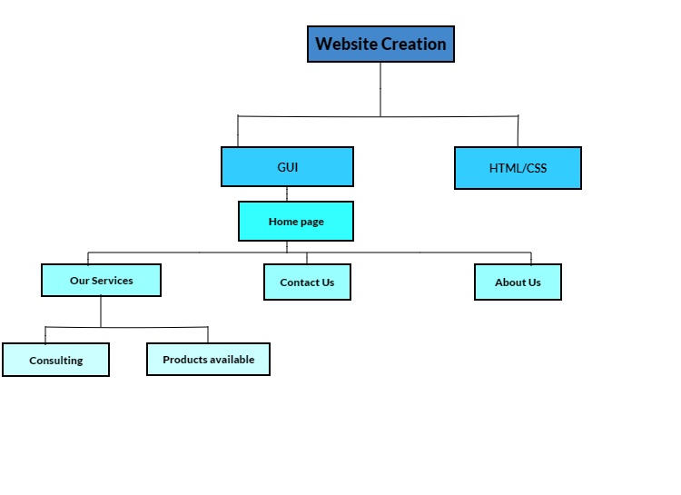

**WIRE FRAME**